**HACKATHON PROJECT**

TOPIC – IDENTIFY COURSES (COURSERA)

**SOFTWARE REQUIREMENTS SPECIFICATIONS**

|  |  |  |  |
| --- | --- | --- | --- |
|  | Prepared By | Reviewed By | Approved By |
| Name | Outsiders | P. Devathilagai |  |
| Role | PATs | Batch Trainer |  |

**Table of Contents**

Table of Contents…………………………………………………………..….......II

1. Introduction…………………………………………………………………..…1

1.1 Intended Audience……………………………………………….......1

1.2 Project Scope…………………………...……………………………1

2. Overall Description…………………………………………….……………….2

2.1 Operating Environment……………………...……………………....2

3. Requirements……………………………………………………………...…….3

3.1Login………………………………………………………………….3

3.1.1Description………………………………………………....3

3.1.2 Functional Requirements……..…………………………...3

**1. INTRODUCTION**

The purpose of this project is to develop an automated web-based solution that identifies and extracts relevant information about educational courses from legitimate online learning platforms such as Coursera.org. The system focuses on three core functionalities: searching for beginner-level web development courses in English, analyzing language learning offerings, and interacting with enterprise-level forms to capture validation errors. This automation aims to streamline the process of course discovery, data extraction, and form validation testing, which are essential for educational research, user experience testing, and enterprise readiness assessments.

**1.1 Intended Audience**

* Business Unit (BU) SME
* Academy coach
* Technical Trainer

**1.2 Project Scope**

This document defines, at a functional level, the business activities encompassed by the system and the rules that govern them. It also outlines key high-level and low-level technical requirements essential for the successful implementation of the system.

The scope of this detailed analysis phase draws heavily on the proposed automation framework, business rules, and technical architecture. It aims to provide a comprehensive understanding of the system’s behavior, structure, and interactions.

Specifically, this document includes:

* **Classification of Requirements by Functional Areas**  
  Requirements is grouped based on core functionalities such as course discovery, language learning analysis, and enterprise form validation. Each functional area is described with its specific objectives and expected outcomes.
* **Process Descriptions**  
  Each process within the system is detailed with its respective inputs, outputs, and data transformation rules. This includes:
  + Searching and filtering web development courses based on beginner level and English language.
  + Extracting course metadata such as name, duration, and rating.
  + Analyzing language learning offers by identifying available languages and categorizing them by proficiency levels.
  + Navigating enterprise-level pages, interacting with form elements, and capturing validation errors.

The system will leverage browser automation techniques to handle dynamic content, multiple windows, dropdown lists, form inputs, and scrolling actions. These capabilities ensure robust interaction with modern web interfaces and accurate data extraction

**2. OVERALL DESCRIPTION**

This section provides a high-level overview of the system, including its environment, user interactions, and general constraints. It outlines the context in which the system will operate and the foundational elements that support its functionality.

**2.1 Operating Environment**

The system will be developed and executed within the following technical environment:

* **Operating System**:  
  The automation framework will run on the **Windows operating system**, compatible with Windows 10 and above.
* **Application Type**:  
  The target application is a **web-based platform**, specifically educational websites such as Coursera.org. The automation will interact with dynamic web elements, forms, dropdowns, and navigation menus within a browser environment.
* **Programming Language**:  
  The automation scripts will be written in **Java**, leveraging object-oriented principles and modular design patterns.
* **Automation Tools & Frameworks**:
  + **Selenium WebDriver**: For browser automation and interaction with web elements.
  + **TestNG**: For test execution management, assertions, and reporting.
  + **Apache POI**: For reading and writing data to Excel files, useful for data-driven testing.
  + **Page Object Model (POM)**: To promote maintainability and reusability by separating page-specific logic.
  + **Behavior-Driven Development (BDD)**: To define test scenarios in a human-readable format.
  + **Cucumber**: For implementing BDD using Gherkin syntax and integrating with Selenium and TestNG.
* **Browser Support**:  
  The system will support modern browsers such as **Google Chrome** and **Microsoft Edge**, with appropriate WebDriver configurations.
* **Network Requirements**:  
  A stable internet connection is required to access and interact with the web application in real time.

**3. REQUIREMENTS**

This part of the requirements document serves to present the "Coursera for Web Development Courses" functionality of the application. It also includes the extraction of all levels in the “Language Learning” section, along with additional workflows related to enterprise forms and course details.

**3.1.1 Functional Requirements**

**3.1.1.1 Req0001 – Web Development Course Search**

* **Req0001a** – The user enters the text “Web Development” in the search box.
* **Req0001b** – The user clicks the search button beside the search bar and validates if it is working properly.

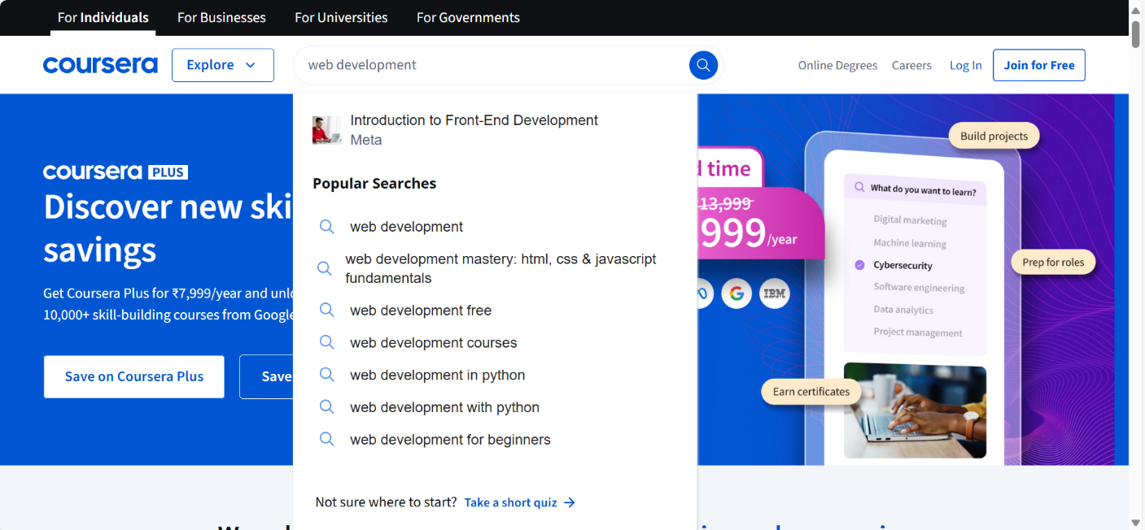

**3.1.1.2 Req0002 – Extracting Course Details**

* **Req0002a** – The user enters the text “Web Development” in the search box and clicks the search button or selects the auto suggestion in the dropdown.
* **Req0002b** – The user filters the level by selecting “Beginner” and language by selecting “English”.
* **Req0002c** – Extract and print top two course result details.

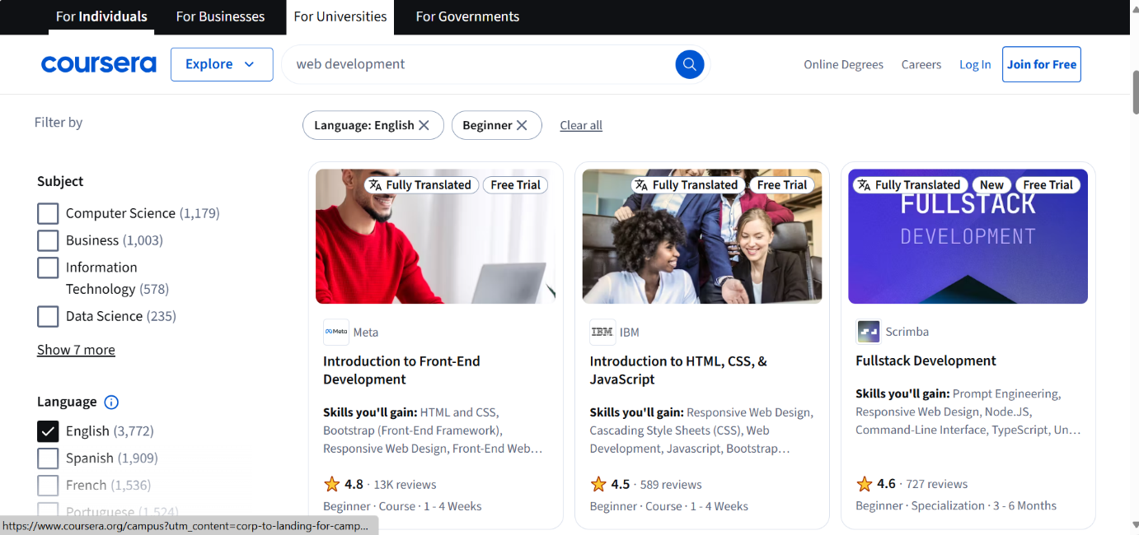

**3.1.1.3 Req0003 – Fetch Language and Level Data**

* **Req0003a** – Navigate to “Language Learning”
* **Req0003b** – Scroll down to “Core skills”.
* **Req0003c** – Navigate to “Spanish Language”
* **Req0003d** – Capture and print language and level data.

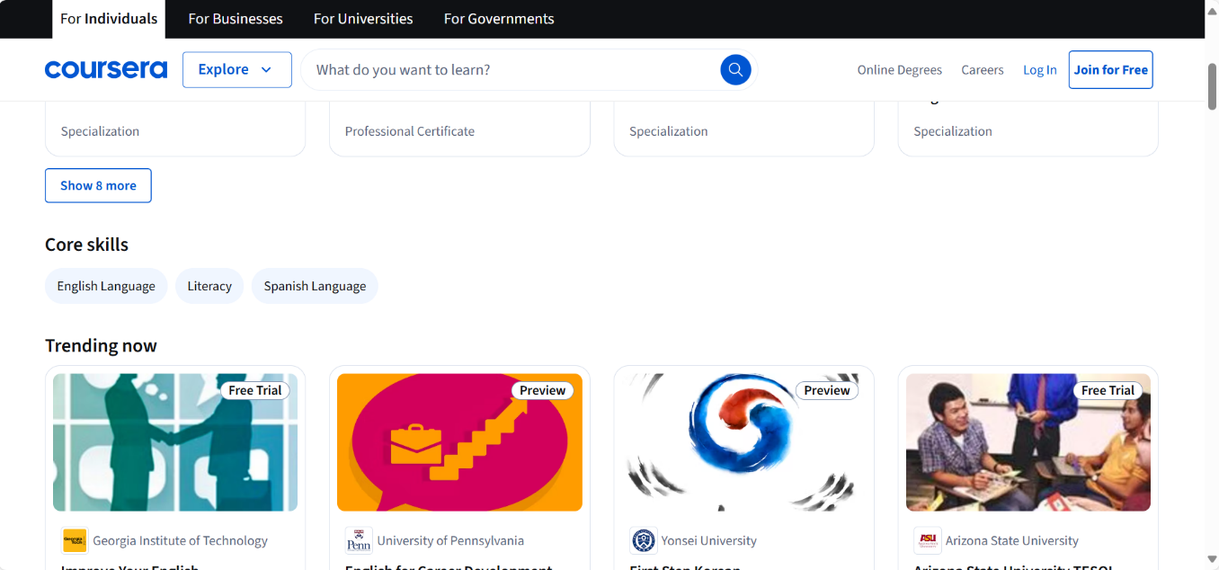

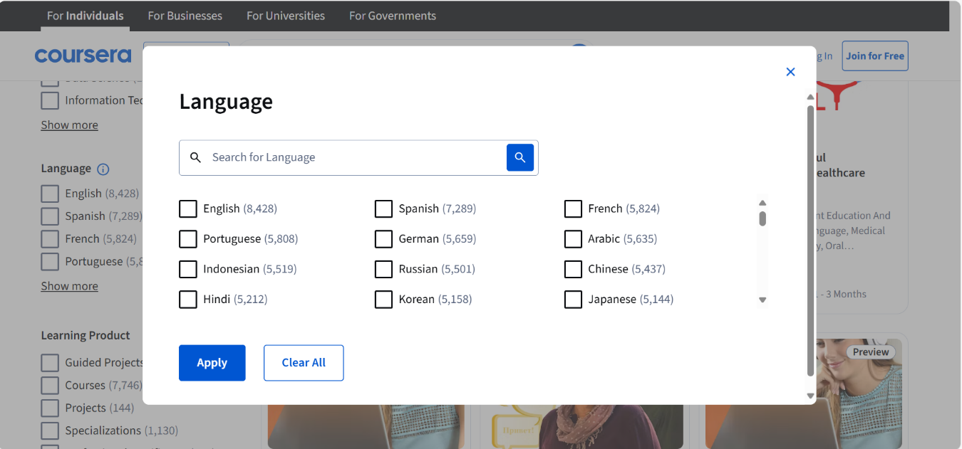

**3.1.1.4 Req0004 – Enterprise Campus**

* **Req0004a** – Navigate to “Coursera home page”.
* **Req0004b** – Navigate to “Enterprise” section and then to “Campus” section.

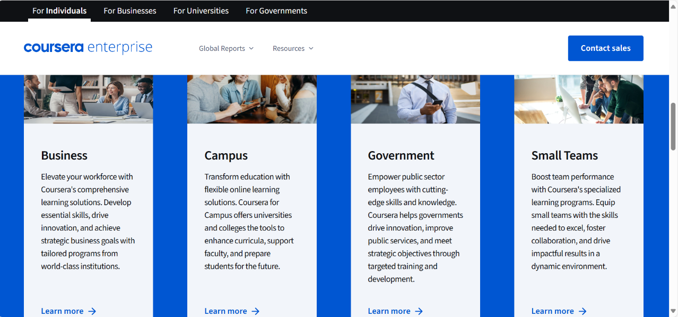

**3.1.1.5 Req0005 – Fill Form and Capture Error Message**

* **Req0005a** – Navigate to the “Enterprise” section and then to “Campus” product page.
* **Req0005b** – Fill the form with test data.
* **Req0005c** – Capture and print the error message.

